**GAMING SECTOR LAUNCHES (Jan’25)**

1. **GeForce RTX 50 Series GPUs**: Nvidia introduced the RTX 50 series graphics cards, including models like RTX 5070, RTX 5070 Ti, RTX 5080, and RTX 5090. These GPUs are powered by the latest Blackwell architecture, featuring fifth-generation Tensor Cores and fourth-generation Ray Tracing Cores.
2. **DLSS 4:** The latest iteration of Nvidia’s Deep Learning Super Sampling (DLSS) technology, DLSS 4, includes multi-frame generation and improved AI features for better game performance.
3. **GeForce NOW Updates:** Nvidia announced updates to its cloud gaming service, GeForce NOW, including native support for Steam Deck and expansion into new regions like India and Latin America.
4. **Nvidia Reflex 2**: This technology aims to reduce PC latency, enhancing the gaming experience by making it more responsive.
5. **AI Features for Nvidia Broadcast:** New AI-powered features for Nvidia Broadcast were introduced, aimed at content creators to improve their streaming and recording quality.

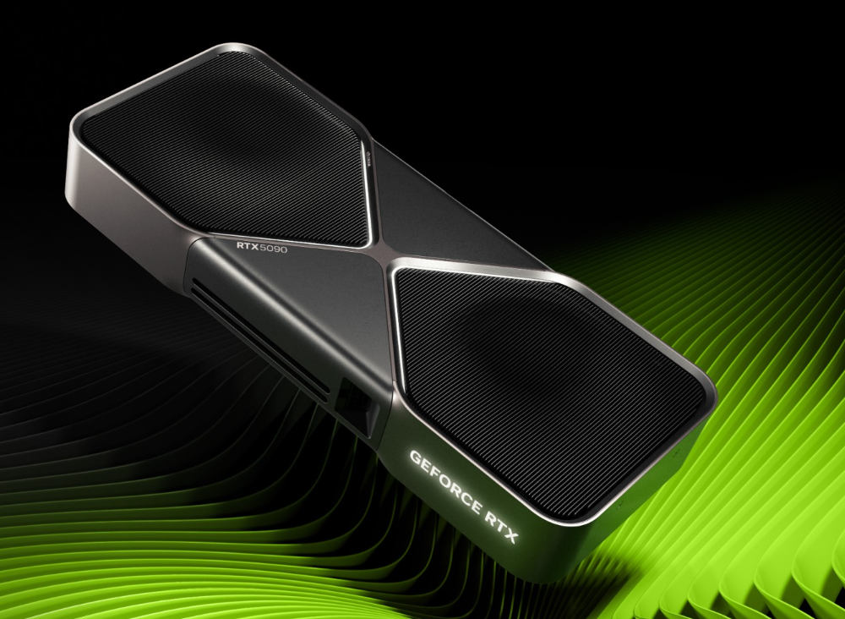 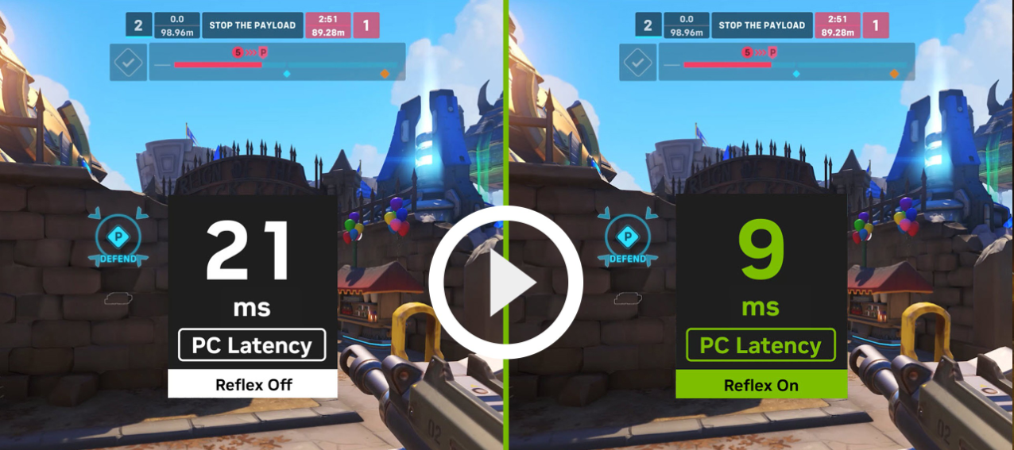

**GeForce RTX 50 Series GPUs Nvidia Reflex 2**